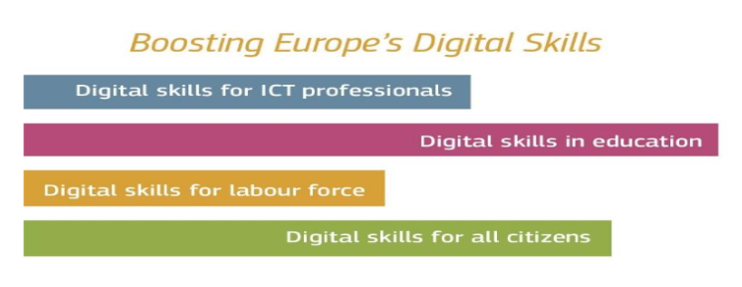
The objective of the news report is to give an update on the progress of your action plan on a monthly basis. More specifically: which activities have been completed, which ones are on-going and/or up-coming, which new initiatives-if any- have been created and which activities were not implemented.
Monthly Report
September 2018

Key actions and milestones (events that took place and are upcoming)

Name of the Organisation: ……………………………………

Α.Title of the Action: …………………………..Number of the Action inthe Action Plan …………………
(If an action includes different sub-actions, please describe briefly in bullet points- max 100 words)

Sub-actions:

B.Description of the Action (max 100 words)

Try to be as specific as possible including the following:
- objectives of the action
- target group (ICT specialists, teachers, citizens, small medium enterprises etc.)
- type of action (upskilling/reskilling, advanced skills in ICT sector, eventetc.),
- type of digital skills ( Digital marketing, coding, soft skills etc.)
- number of participants
- number of beneficiaries
- Information on the event (location, agendaetc.)

- Benefits(max 30 words)

Describe in bullet points the expected benefits after the implementation of the action:

- Partnerships(max 30 words)

- List partners, if any, involved in the design and implementation of the action indicating their key role

Communication activities

- Add photos of the action, promotion material, news articles, social media posts etc.
- More information can be found at: http://.... (please add URL of the action).

